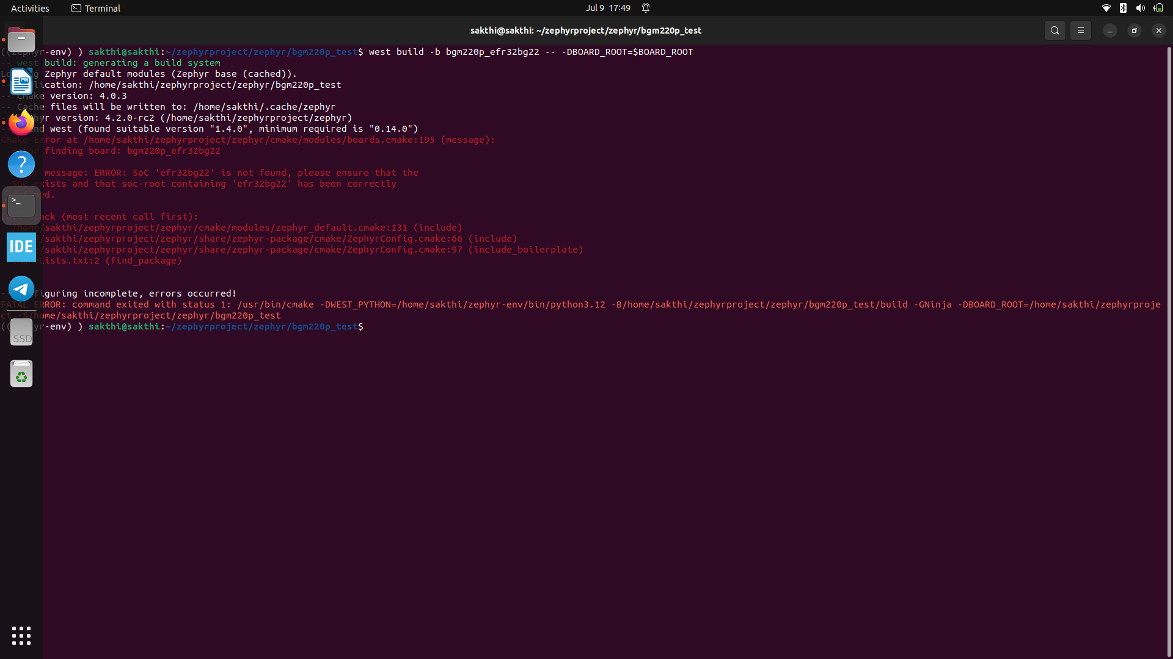
Problem Summary:
When building a Zephyr project using the custom board bgm220p_efr32bg22, the following error is encountered:
ERROR: SoC 'efr32bg22' is not found, please ensure that the SoC exists and that soc-root containing 'efr32bg22' has been correctly added.

Root Cause:
Zephyr’s CMake system cannot find the SoC definition for efr32bg22, which is required by the custom board bgm220p_efr32bg22. This is due to a missing or incorrectly configured SoC directory.

Solution Steps:

1. Verify SoC Directory Exists
Ensure the directory exists:
zephyrproject/zephyr/soc/arm/silabs/efr32bg22/
If not, create it and include at least the following files:
- CMakeLists.txt
- Kconfig.soc
- soc.h
- Startup and linker files as needed
Use other Silabs SoCs like efr32mg_s2 as references.

2. Register SoC in Kconfig.soc
Edit:
zephyrproject/zephyr/soc/arm/silabs/Kconfig.soc
Add:
source "soc/arm/silabs/efr32bg22/Kconfig.soc"

3. Reference SoC in Board Device Tree
Ensure your bgm220p_efr32bg22.dts includes:
#include <silabs/efr32bg22.dtsi>

4. Define SoC in Board YAML File
Edit:
zephyrproject/boards/silabs/bgm220p_efr32bg22/bgm220p_efr32bg22.yaml
Add:
soc: efr32bg22

5. Verify BOARD_ROOT Environment Variable
Ensure BOARD_ROOT is correctly set:
export BOARD_ROOT=/home/sakthi/zephyrproject/boards

6. Add SoC Path to ZEPHYR_EXTRA_MODULES (if custom)
If the SoC is not in the main Zephyr tree:
export ZEPHYR_EXTRA_MODULES=/home/sakthi/zephyrproject/soc

7. Clean and Rebuild
After making the changes, clean and rebuild:
west build -b bgm220p_efr32bg22 --pristine

8. Check Board Detection
To verify that the board is recognized:
west boards --board-root=$BOARD_ROOT | grep bgm220p

Conclusion:
The error occurs due to a missing or unregistered SoC. By ensuring the SoC files exist, are properly configured, and environment variables are set correctly, the build process can be completed successfully.

